

**Technical Documentation**

**Document ID:5453**

**5466**

**Document Version:1.0**

**Author: Shashanth Jogi**

**Manjula N**

## **Create Embitel Login module for Magento 2**

Name of the module is defined as Embitel->namespace, Login->modulename

### **Create etc/module.xml file.**

app/code/Embitel/Login/etc/module.xml

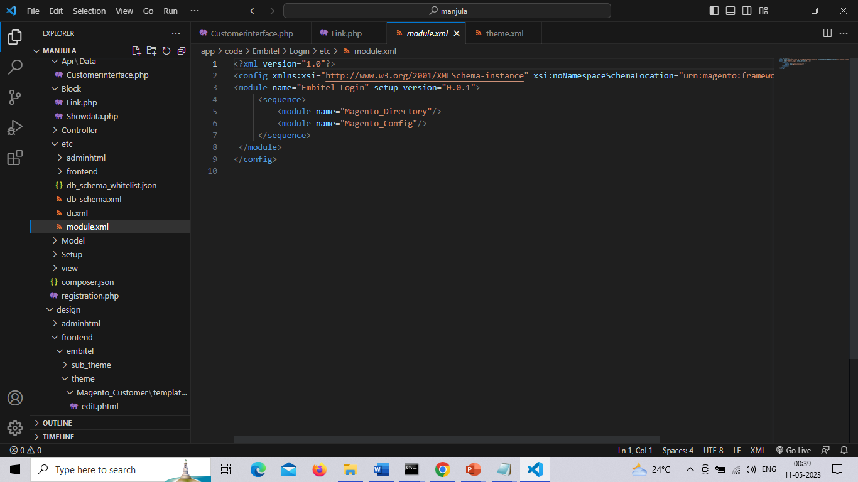

### **Create etc/registration.php file.**

app/code/Embitel/Login/etc/registration.php

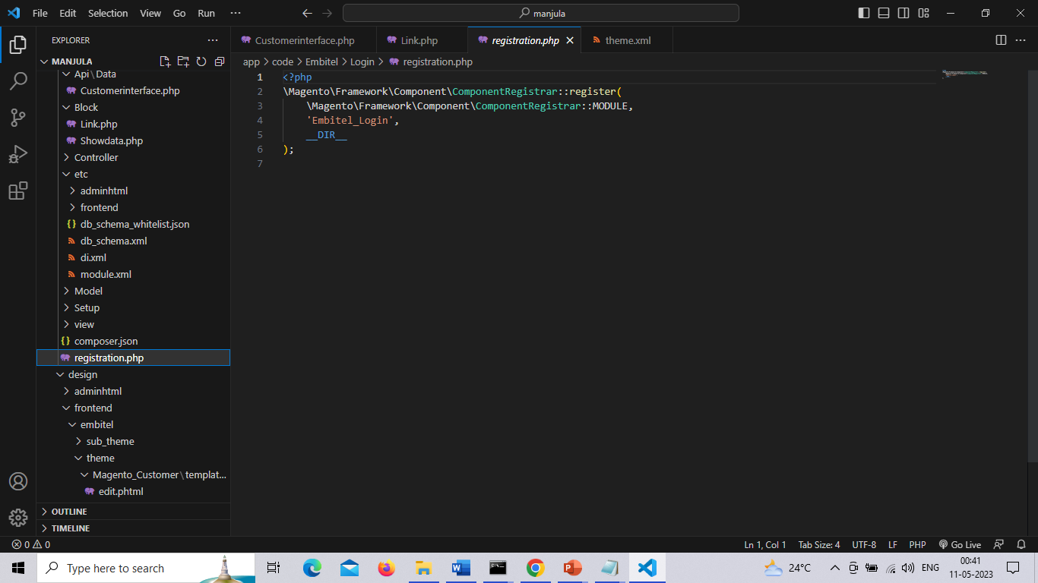

**Create etc/db_schema.xml file**

app/code/Embitel/Login/etc/db_schema.xml

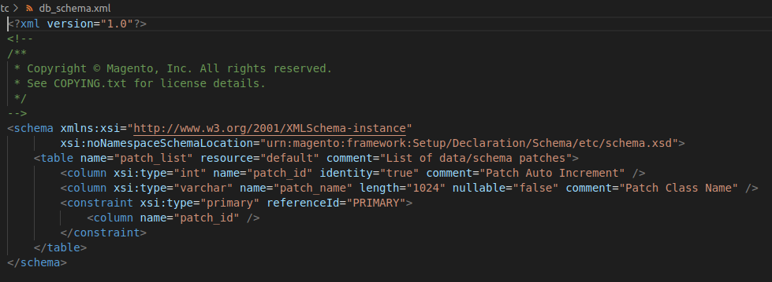

**Create di.xml**

app/code/Embitel/Login/etc/di.xml

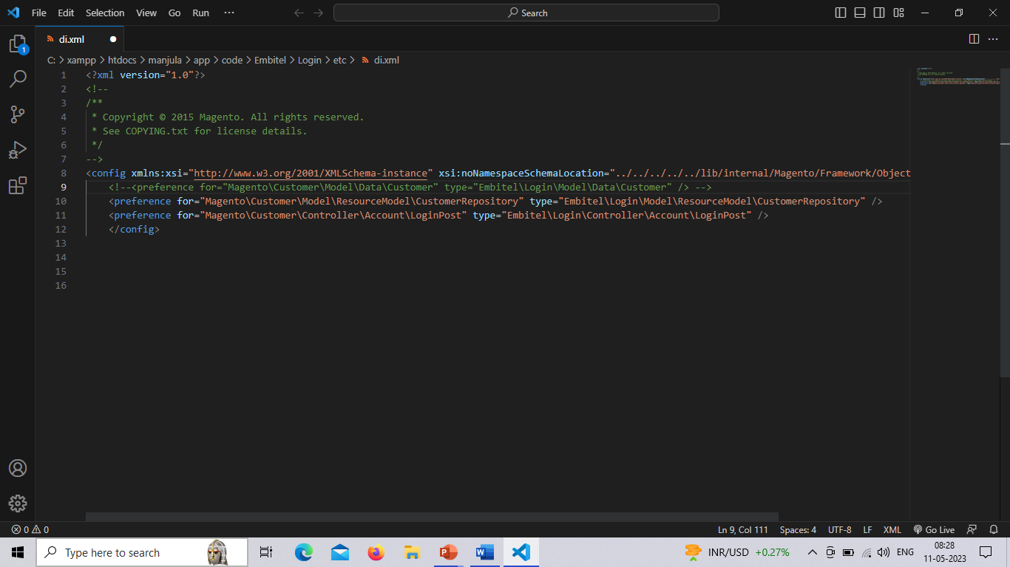

**Create route.xml**

app/code/Embitel/Login/etc/route.xml

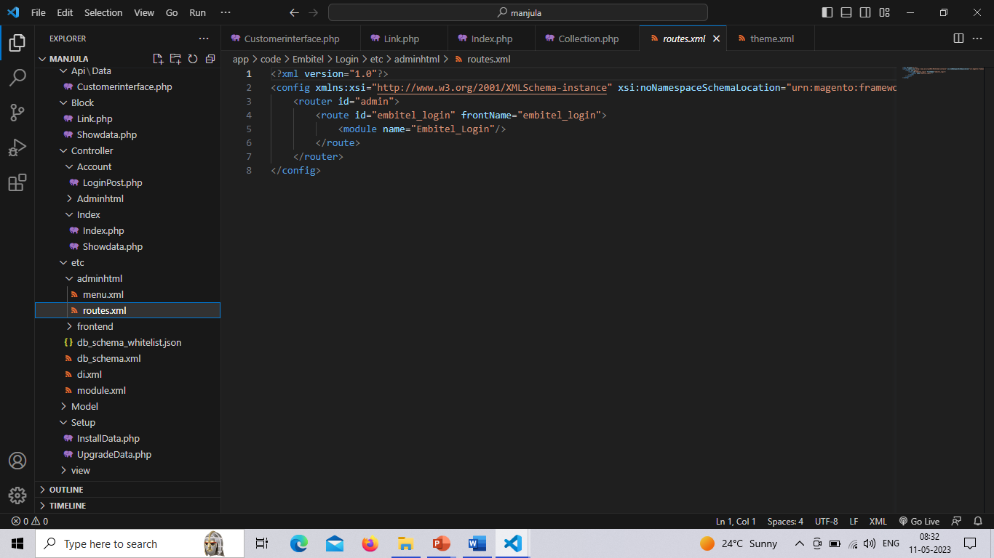

**Create menu.xml**

app/code/Embitel/Login/etc/menu.xml

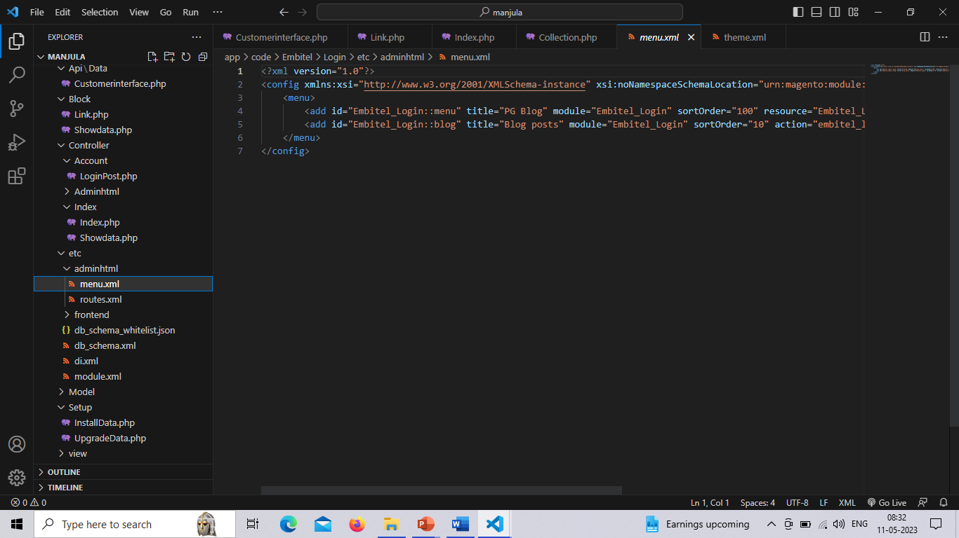

**Overridden files:**

We have overridden **login.phtml** file using layout XML directly and add template file to the theme folder under **Magento_Customer** theme module.

login.phtml file used to display login form in Frontend area.

The path is app/design/frontend/embitel/theme/theme.xml

**Theme.xml**

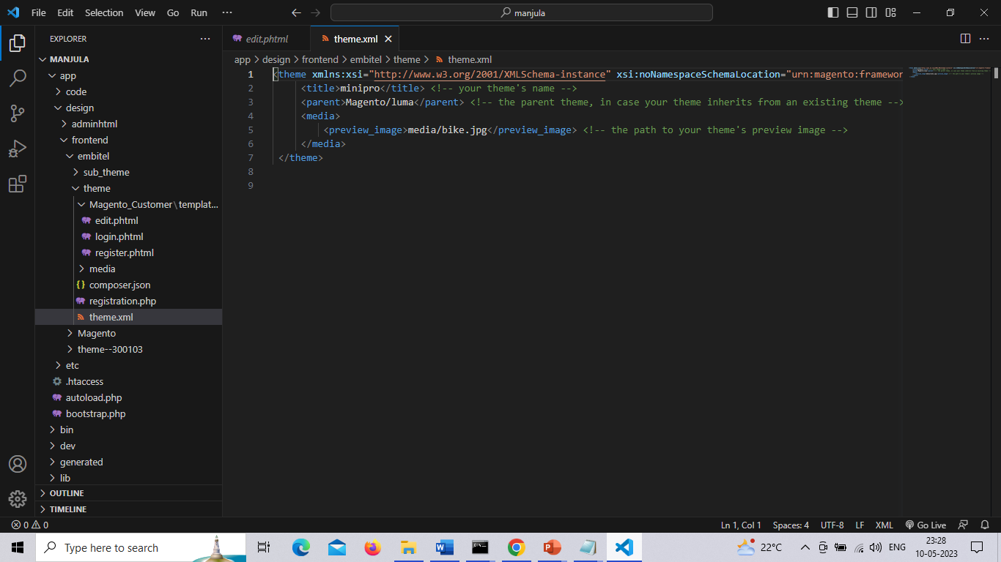

**login.phtml**

The path is app/design/frontend/embitel/theme/Magento_Customer/templetes/form/login.phtml

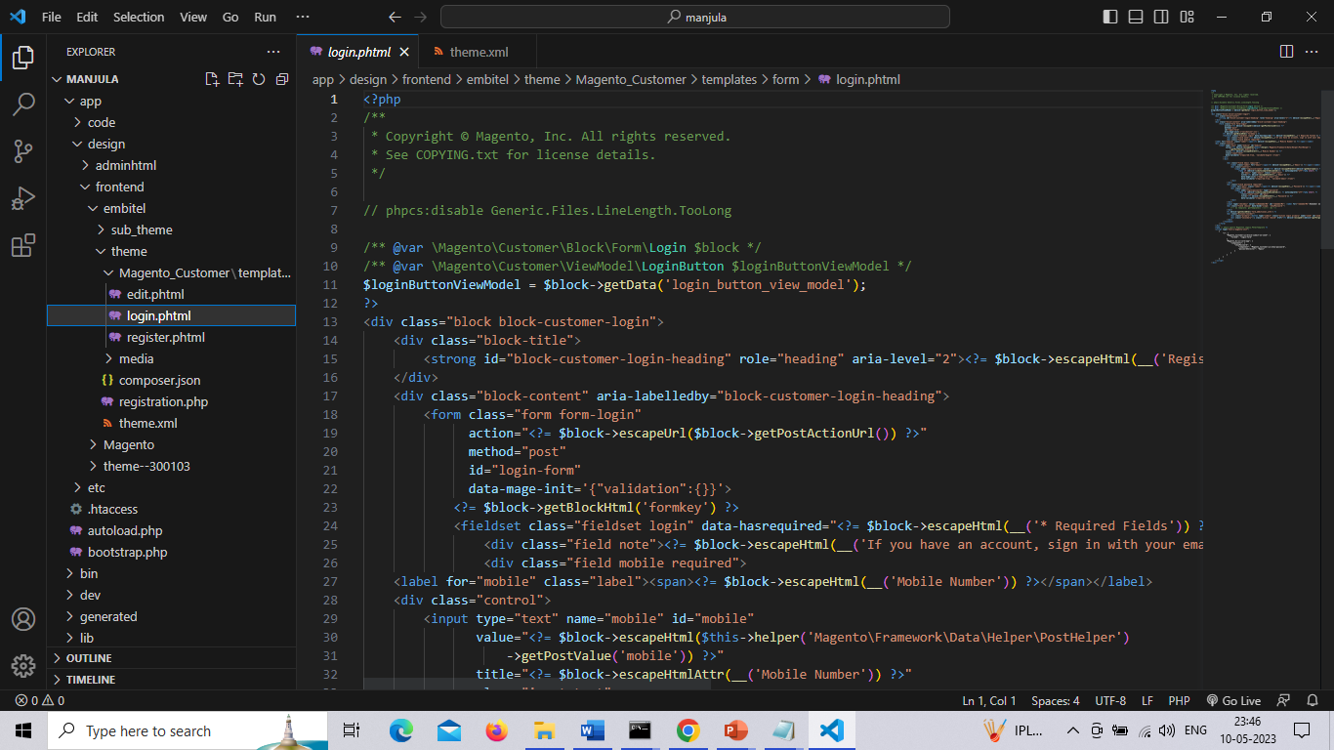

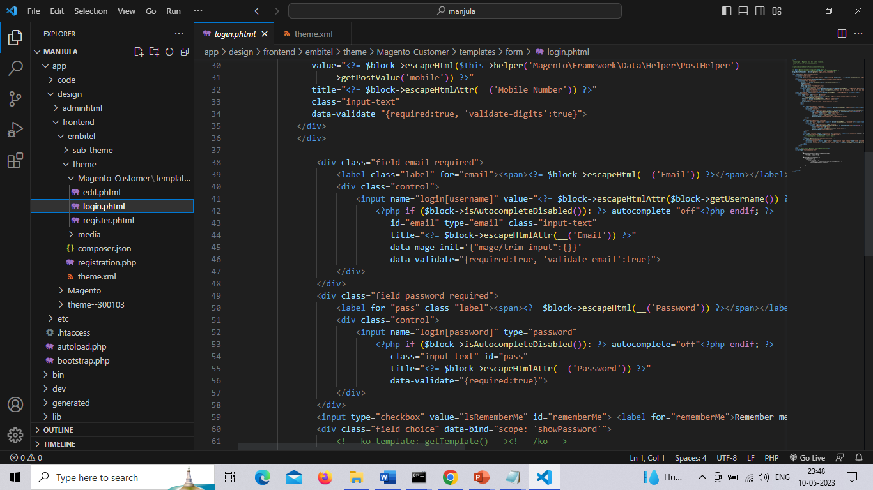

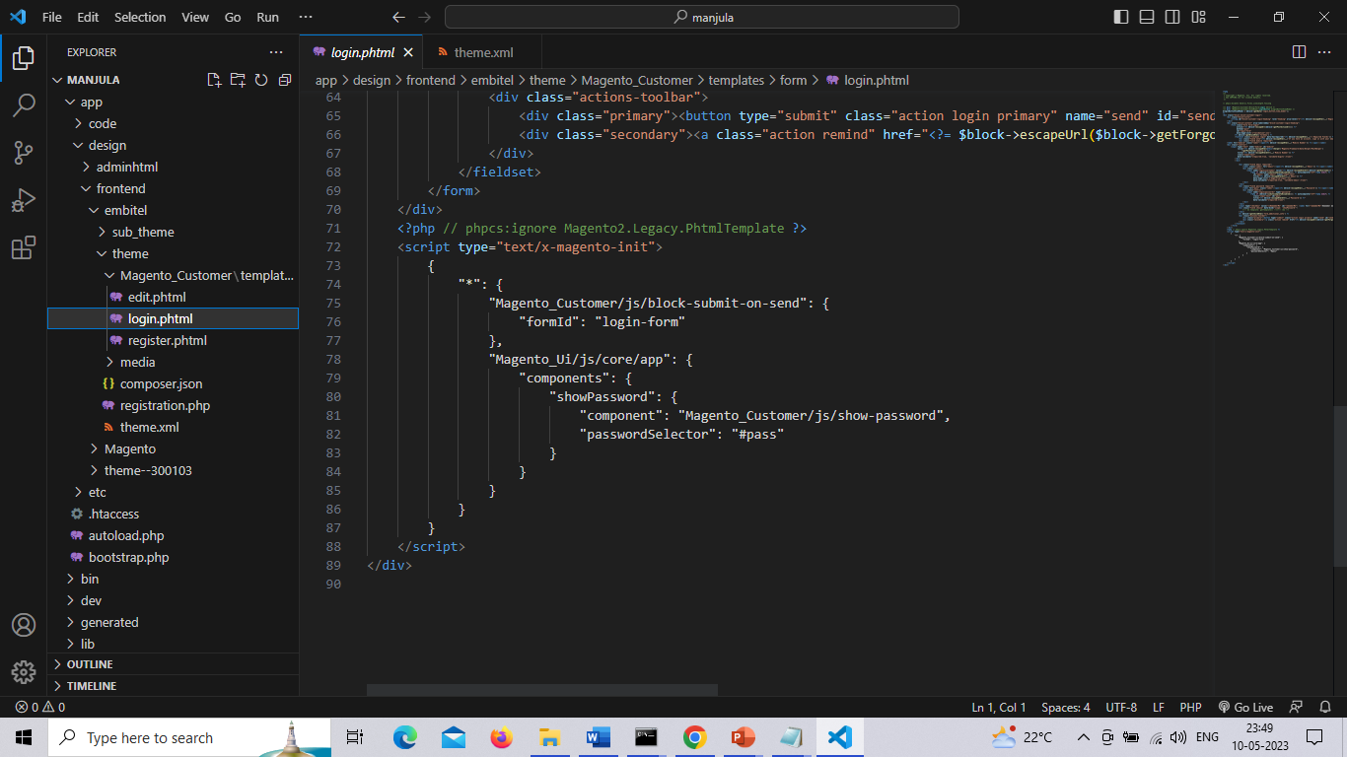

**edit.phtml**

The path is app/design/frontend/embitel/theme/Magento_Customer/templetes/form/edit.phtml

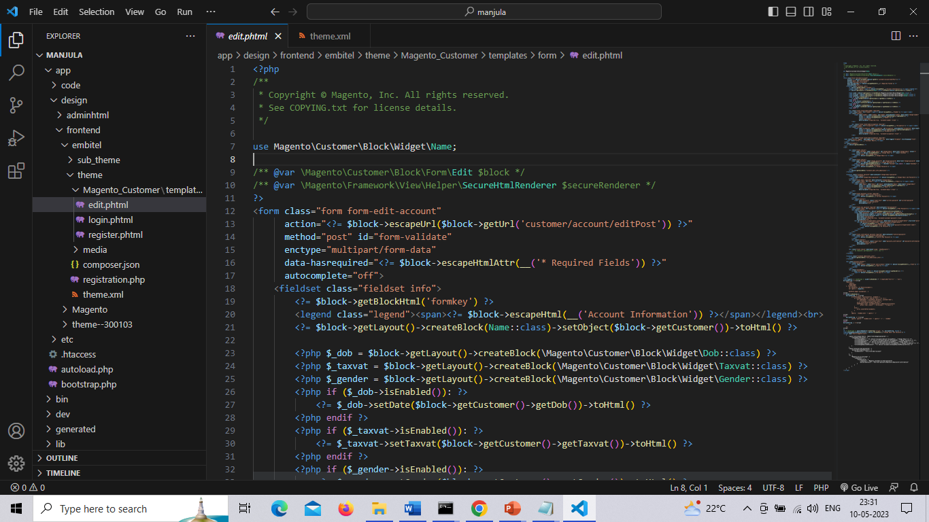

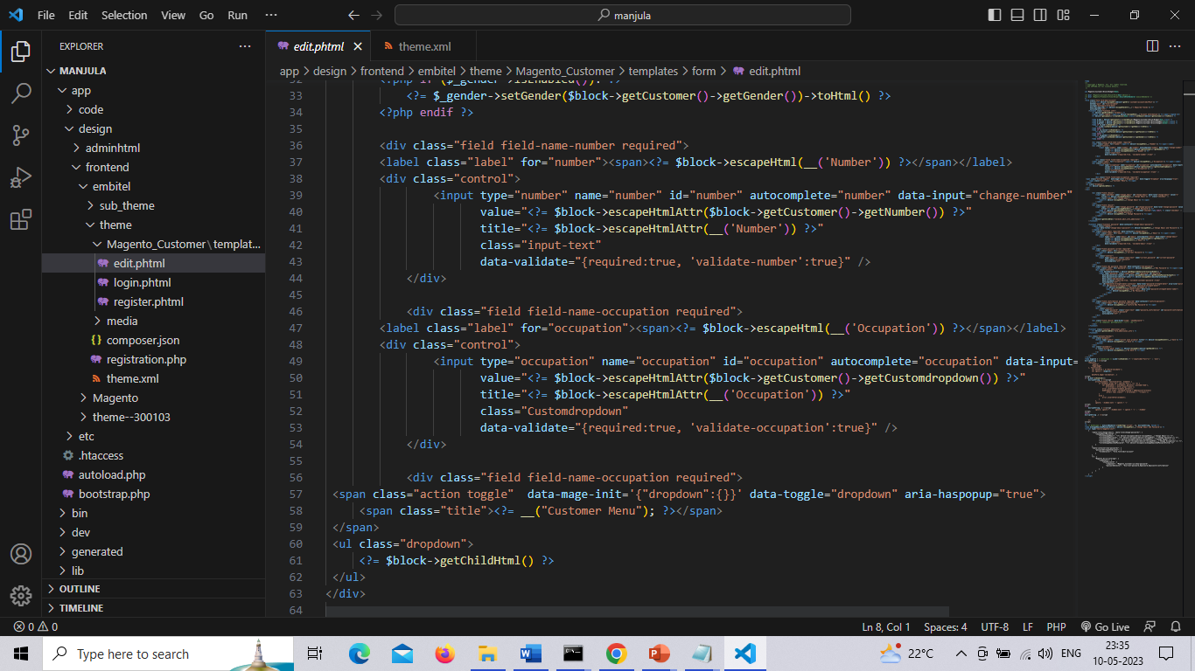

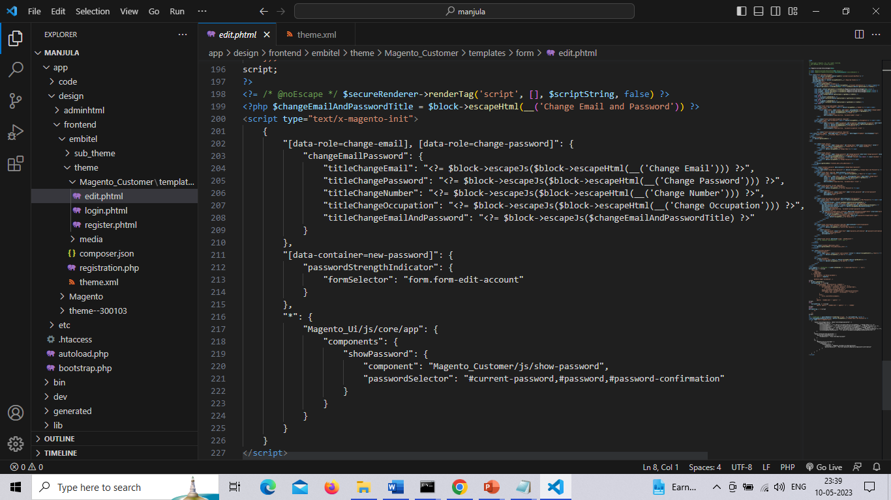

**register.phtml**

We have added new fields in registration form, app/design/frontend/default/default/template/customer/form/register.phtml

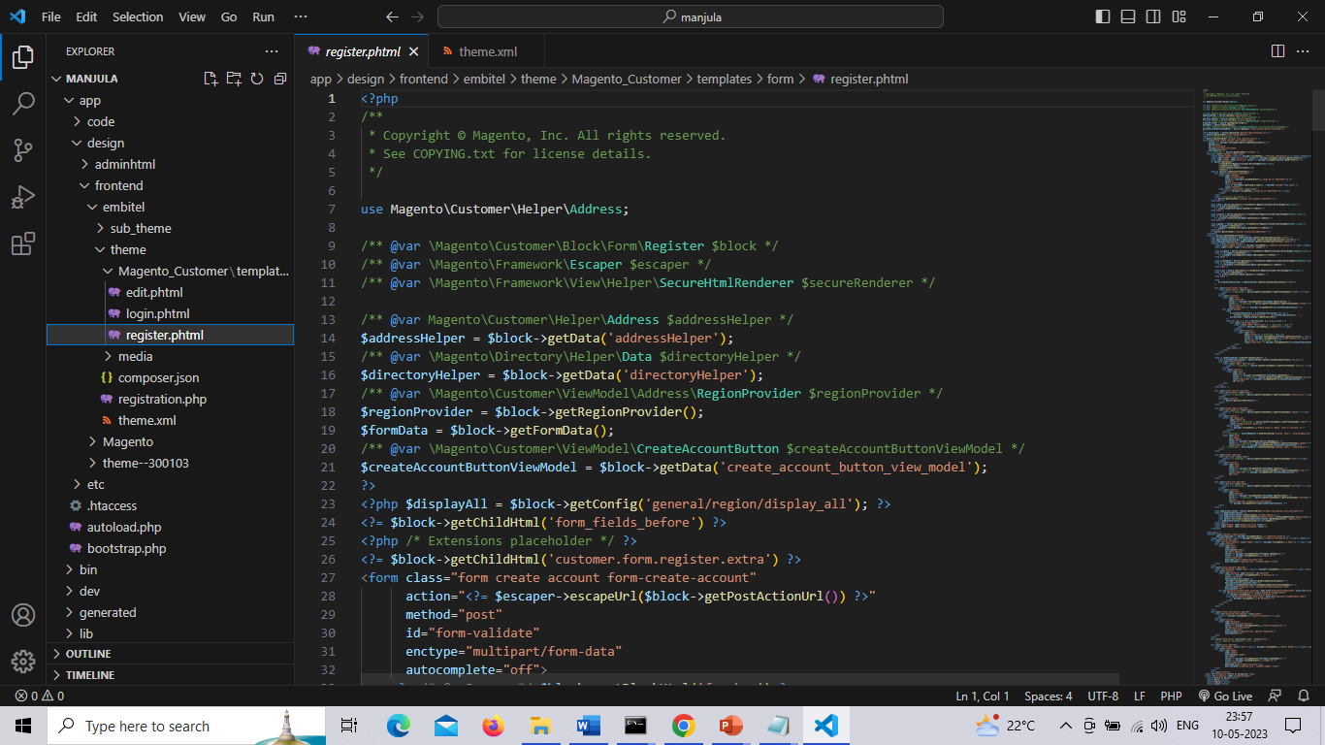

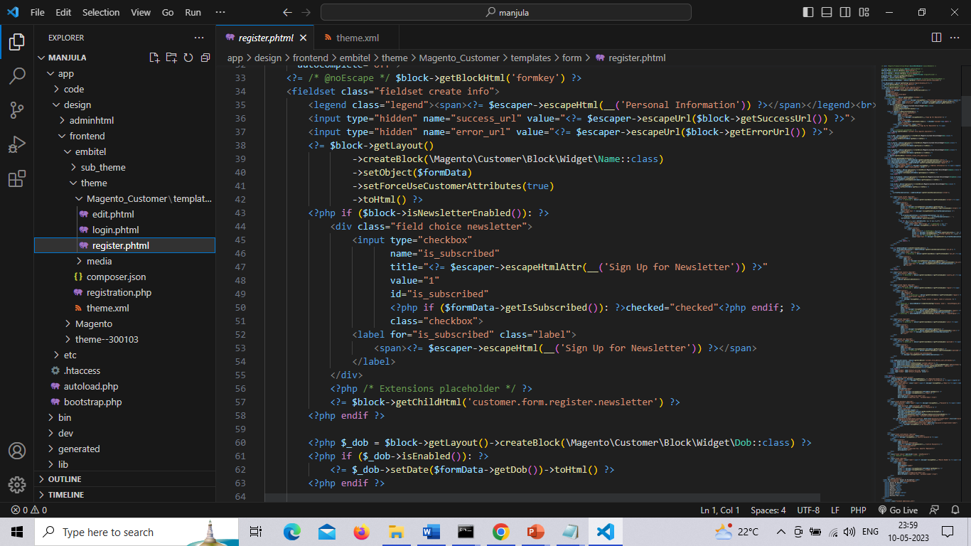

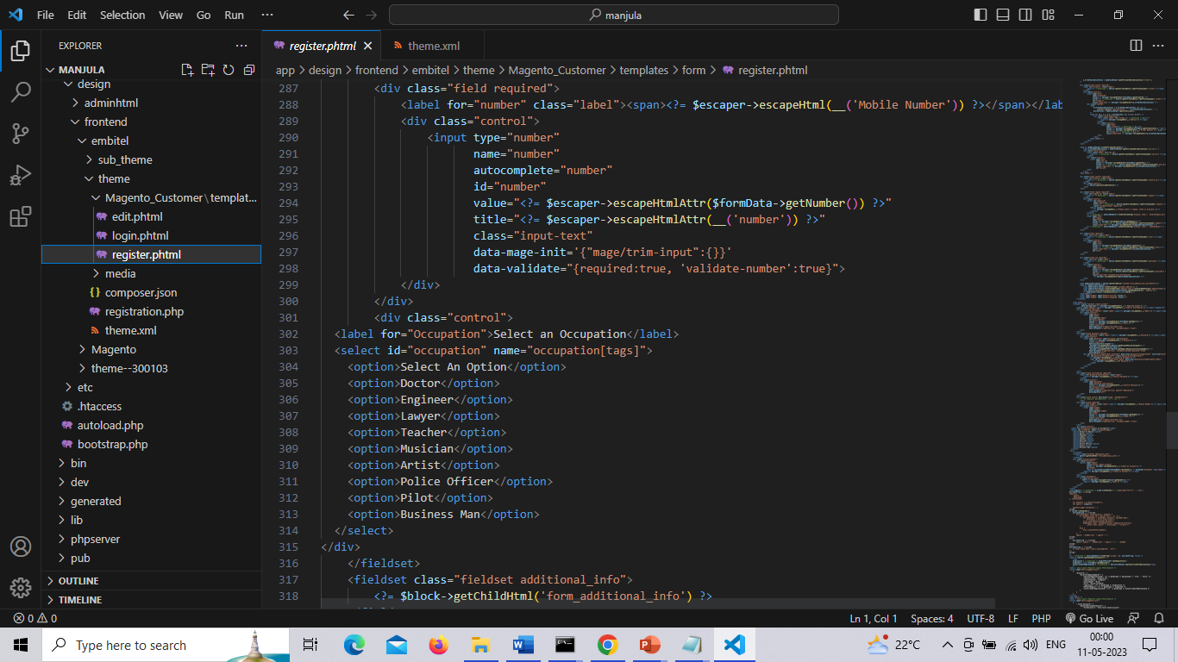

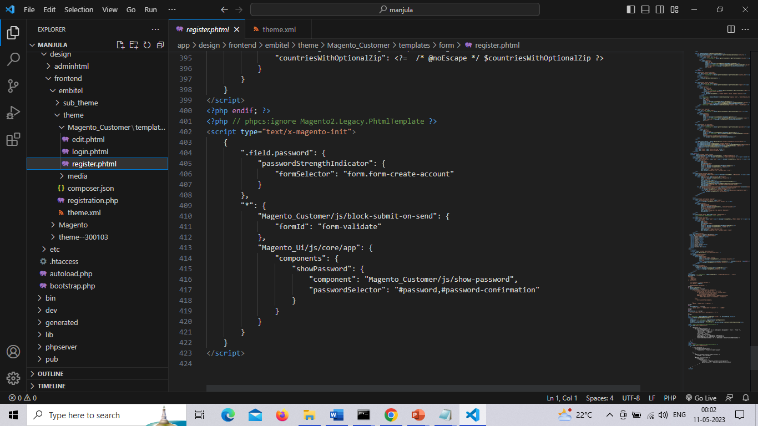

**Customerinterface.php**

Customer interface for creating customer attribute in Magento 2

The path is app/code/Embitel/Login/Api/Data/Customerinterface.php

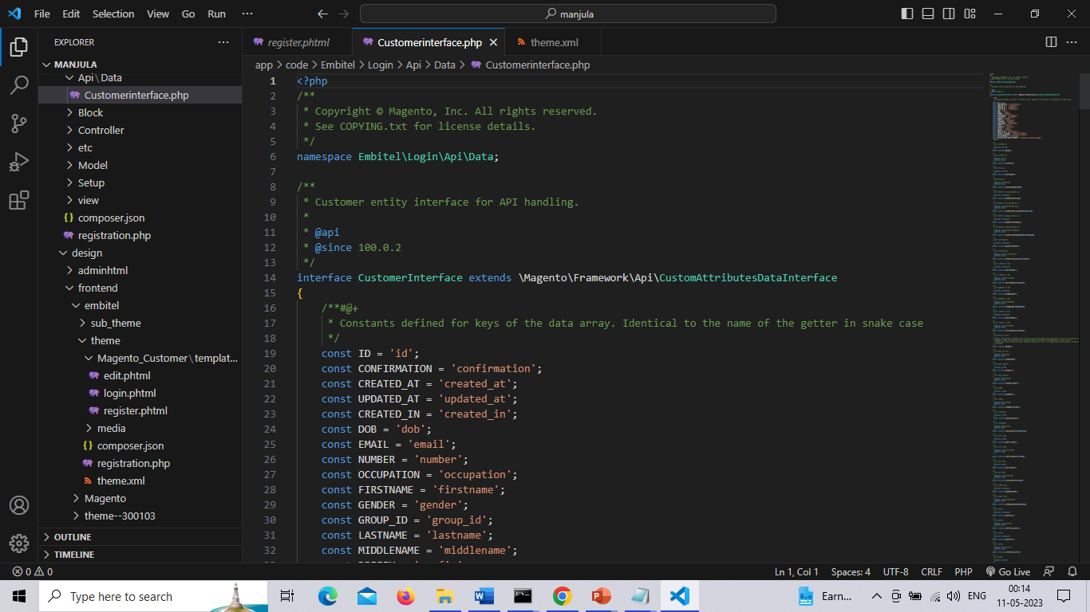

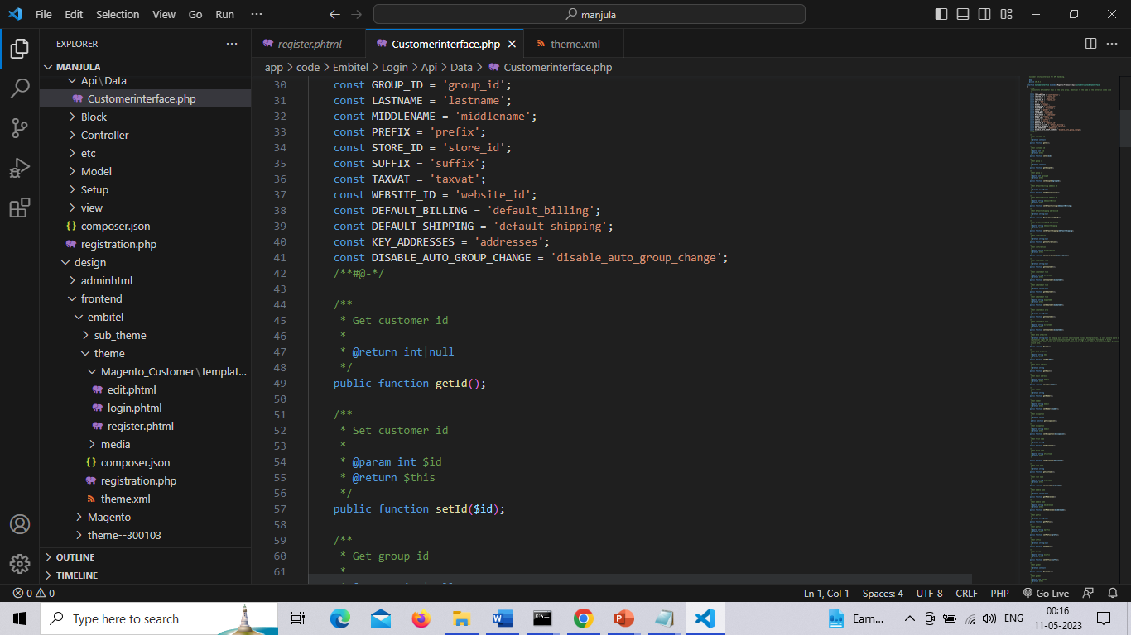

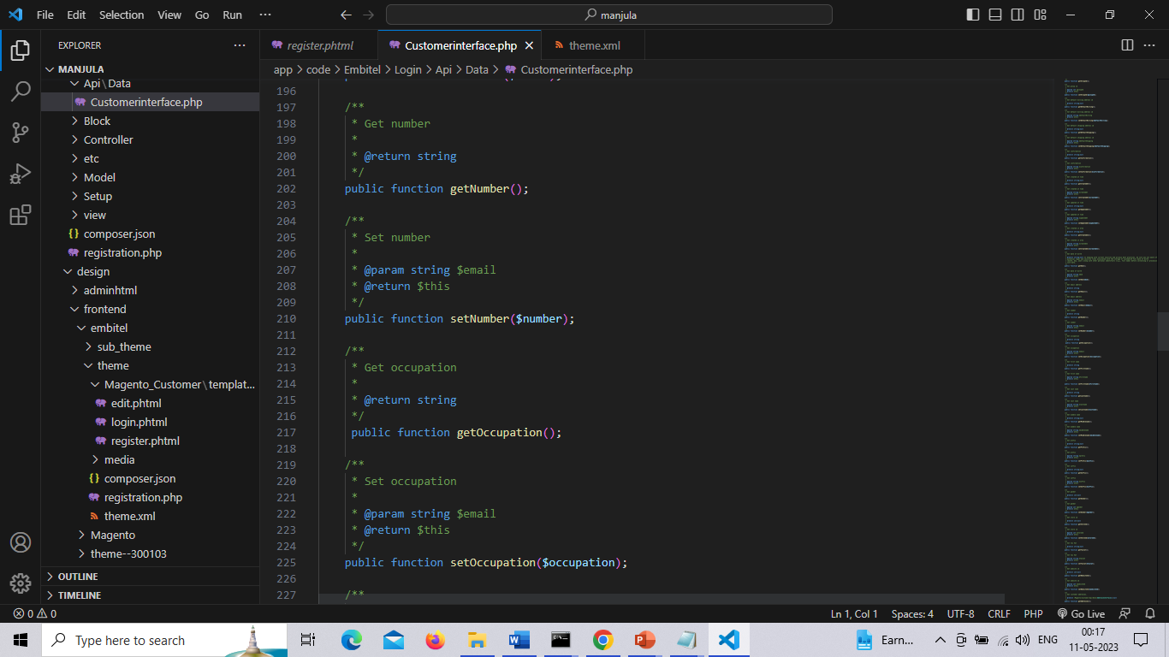

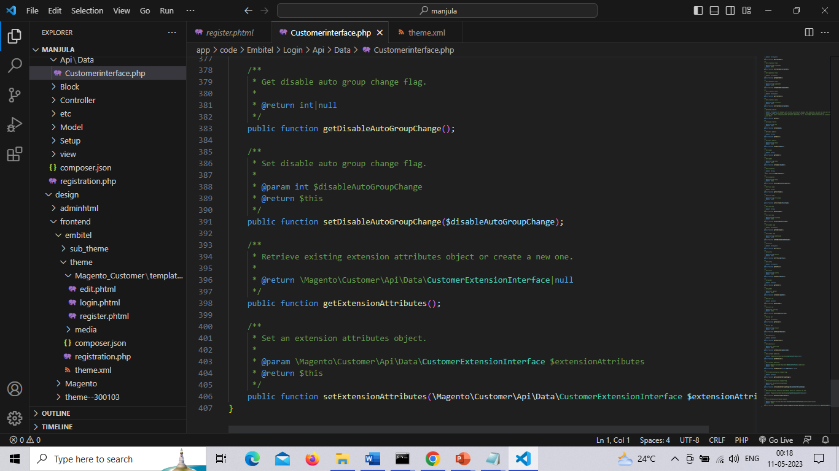

**Link.php &showdata.php**

Link.php & showdata.php is to display the data in frontend page

The path is app/code/Embitel/Login/Block/link.php

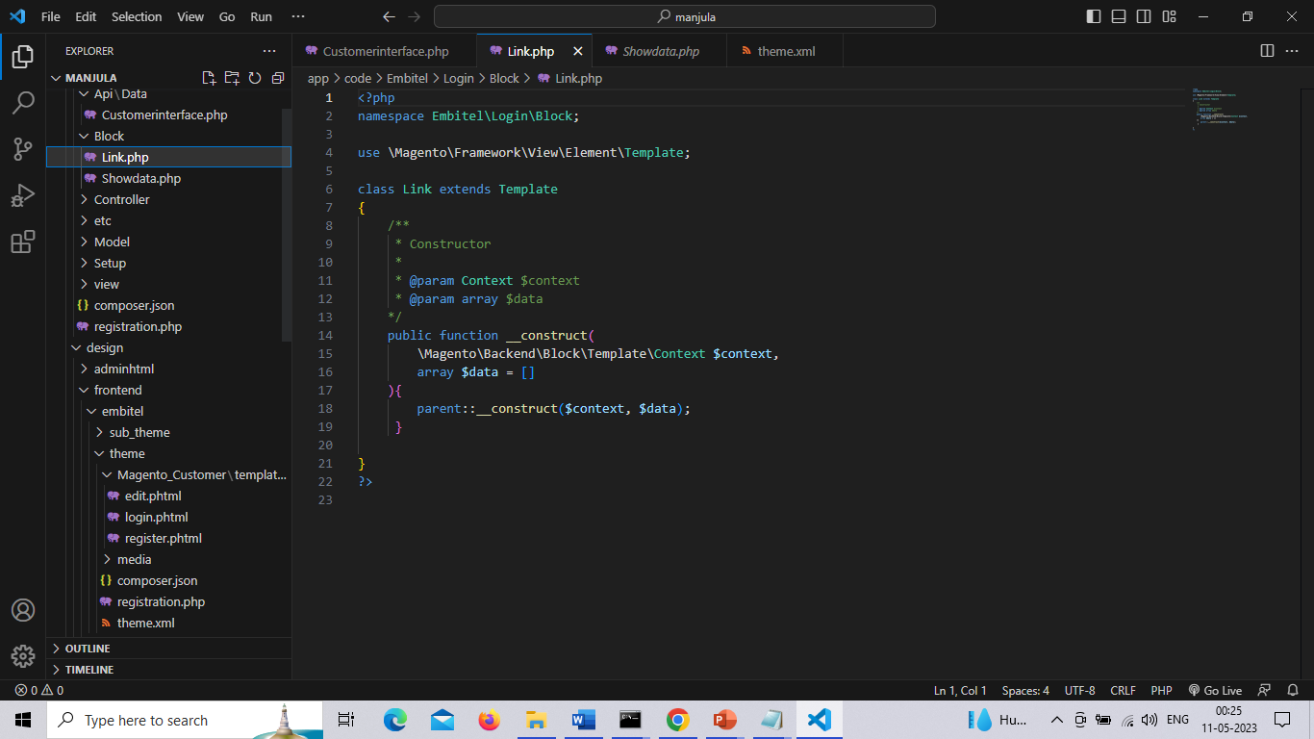

**Showdata.php**

The path is app/code/Embitel/Login/Block/showdata.php

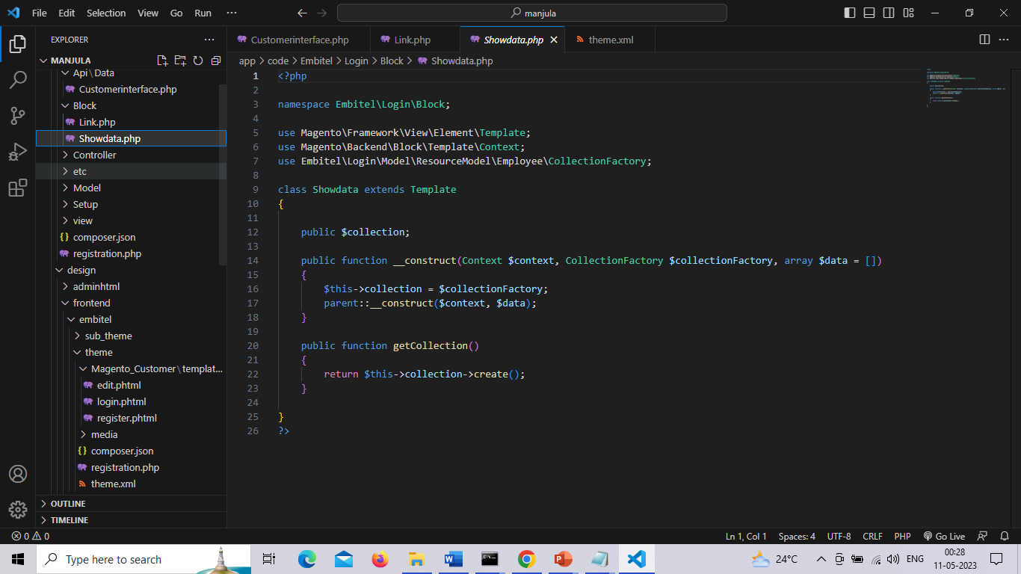

**Loginpost.php**

Customer can login with the mobile number or email id.

**app\code\Embitel\Login\Controller\Account\LoginPost.php**

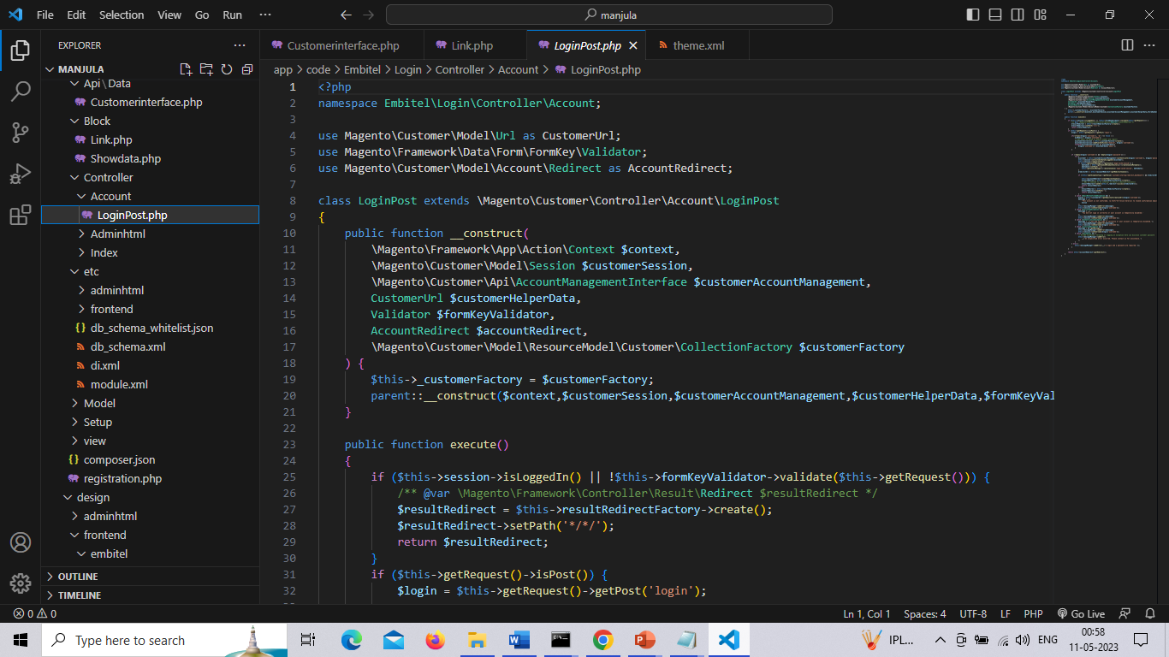

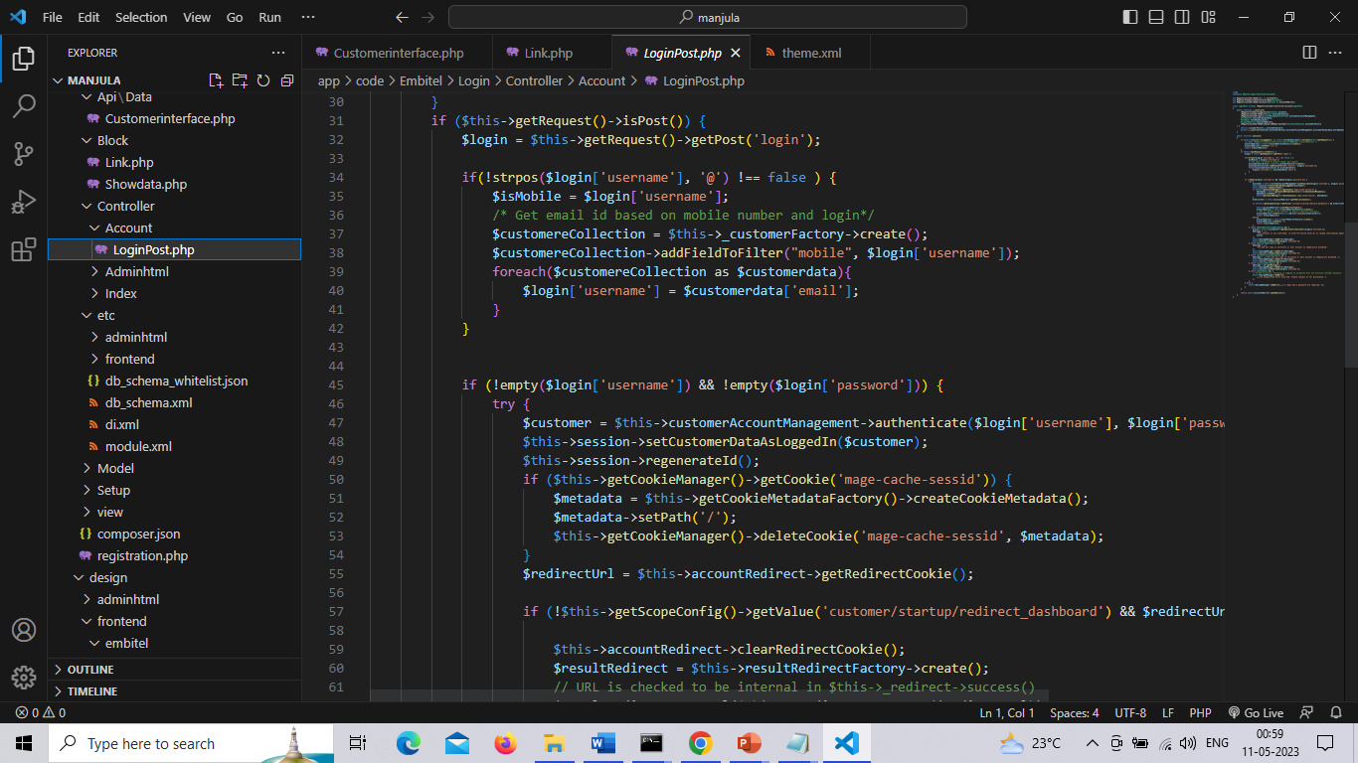

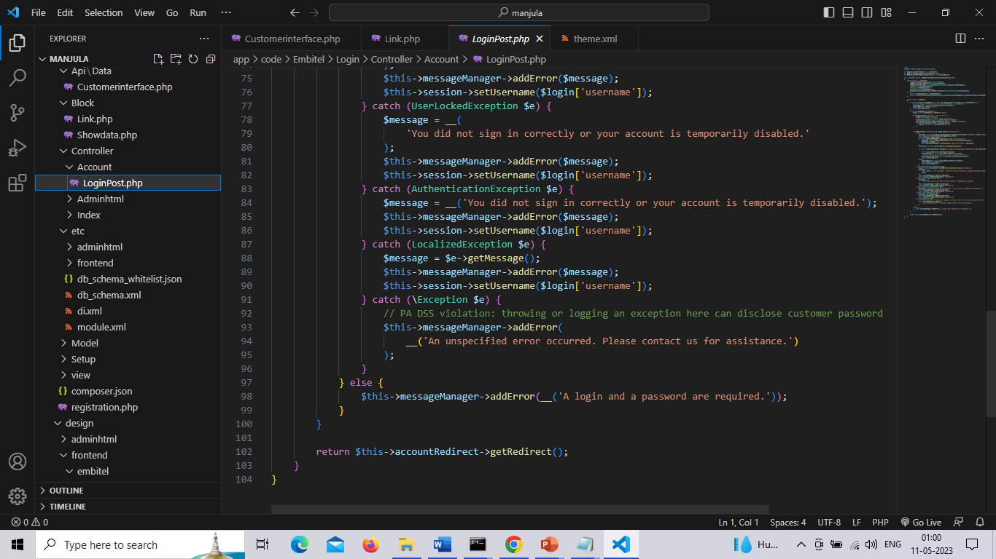

Customer.php

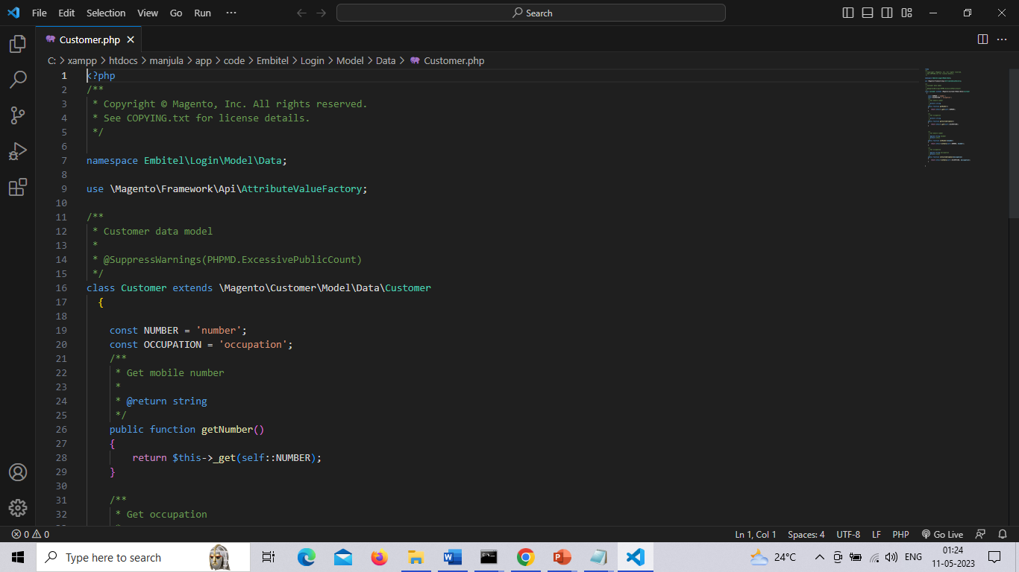

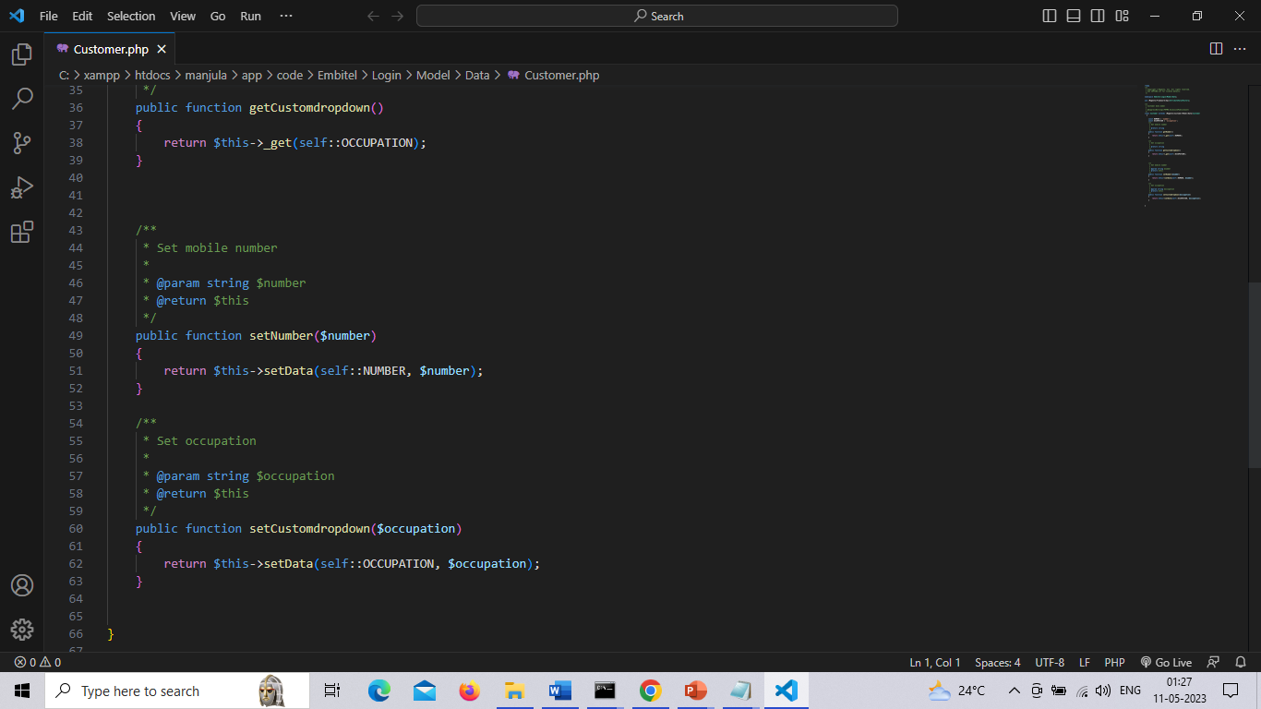

Customerrepository.php

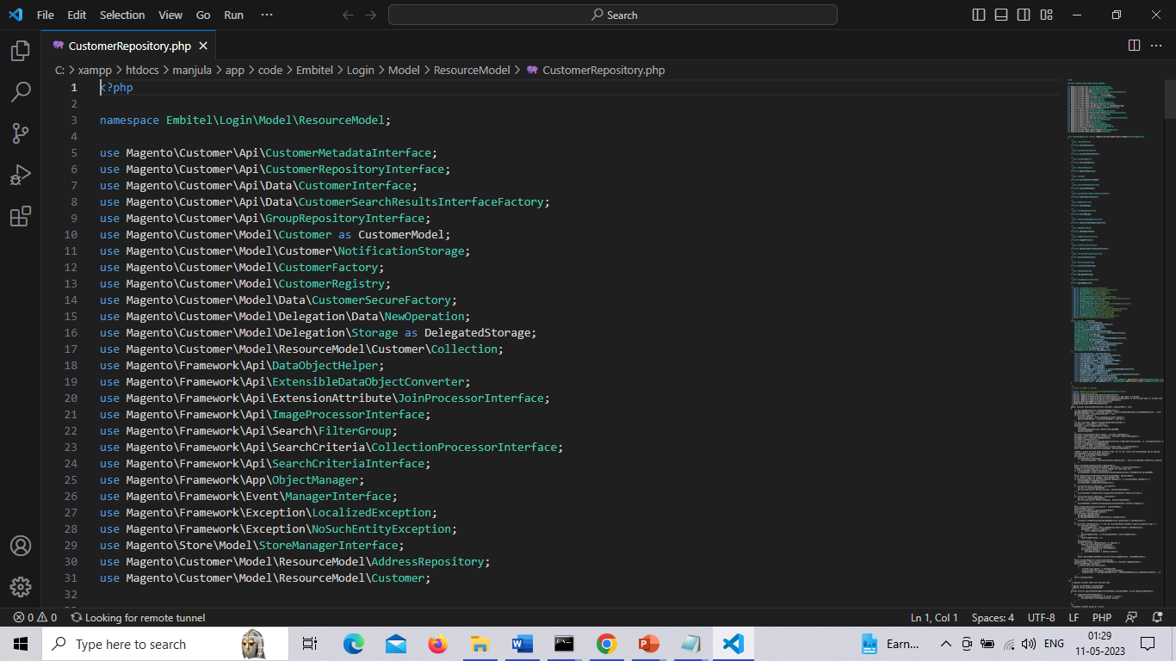

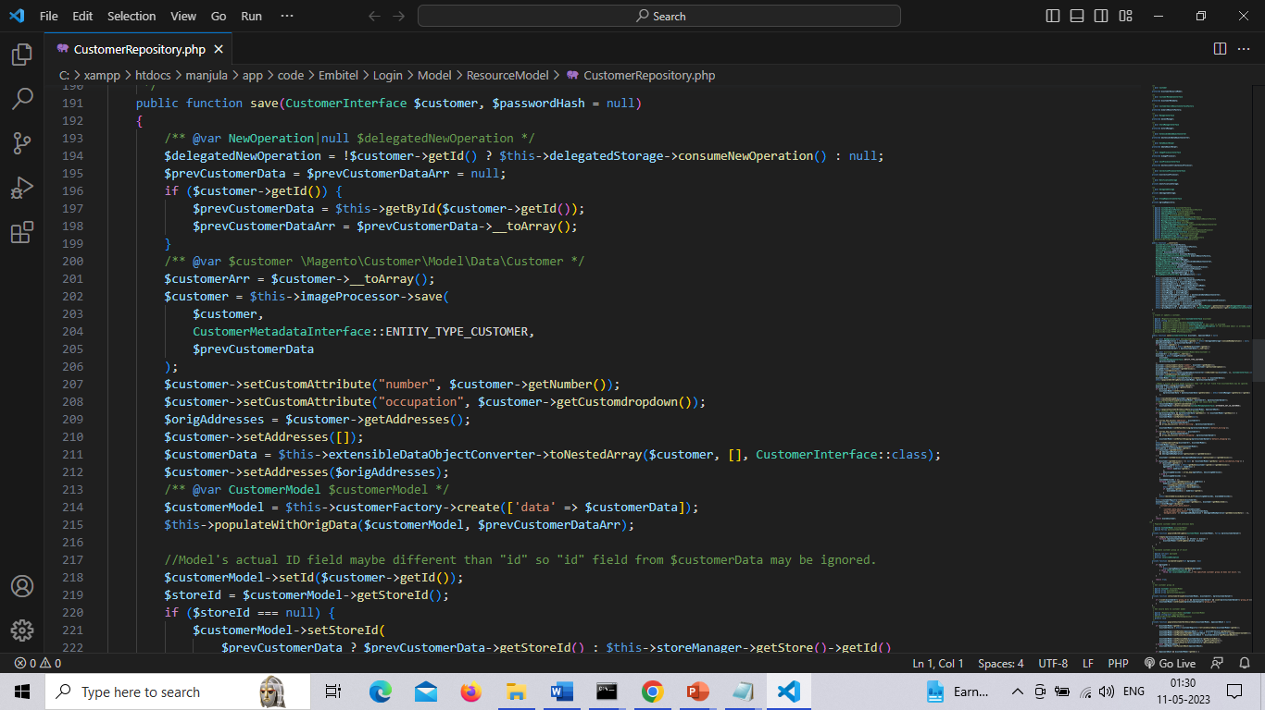

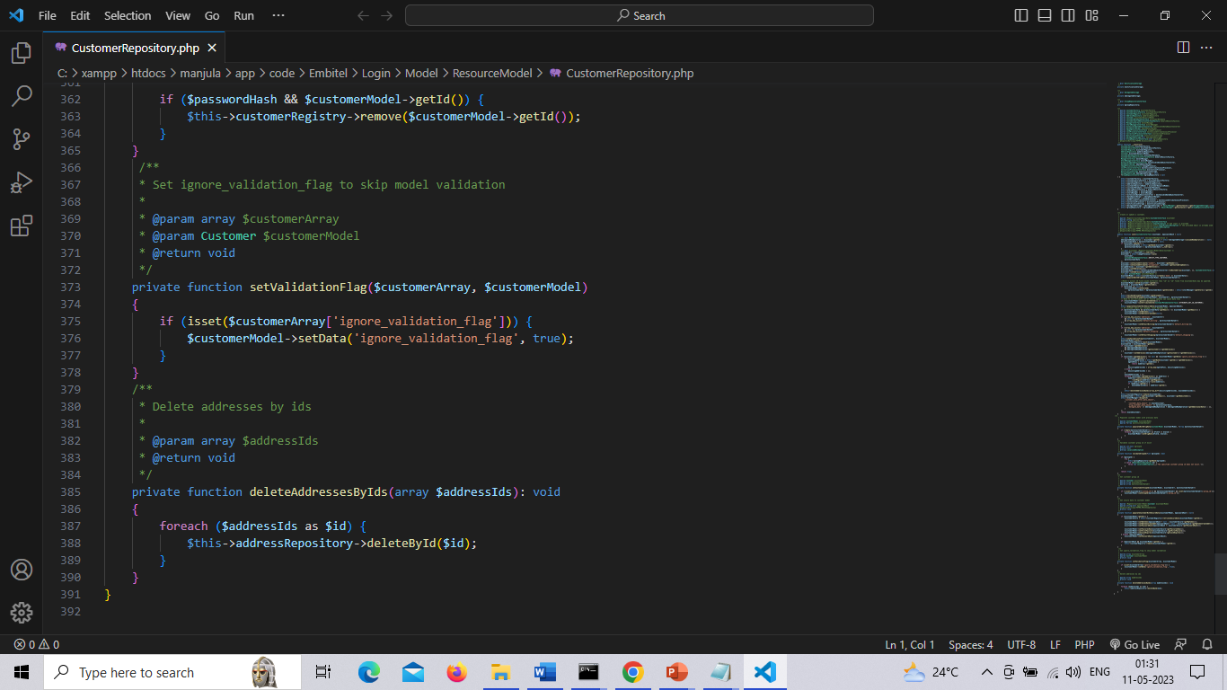

Customdropdown.php

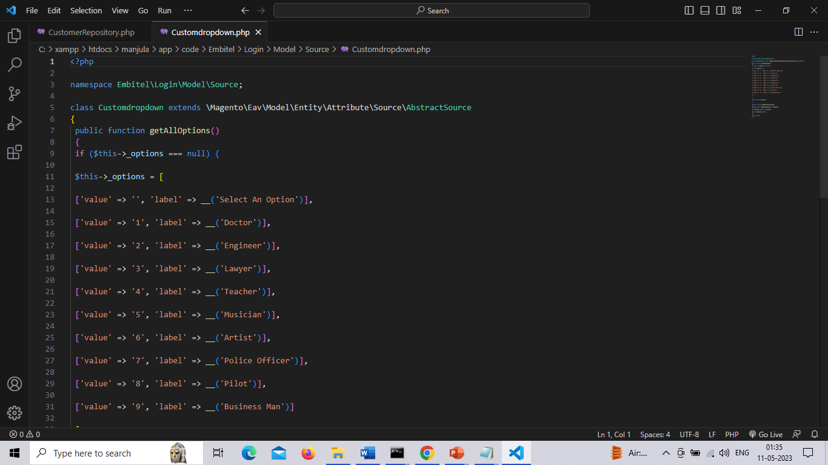

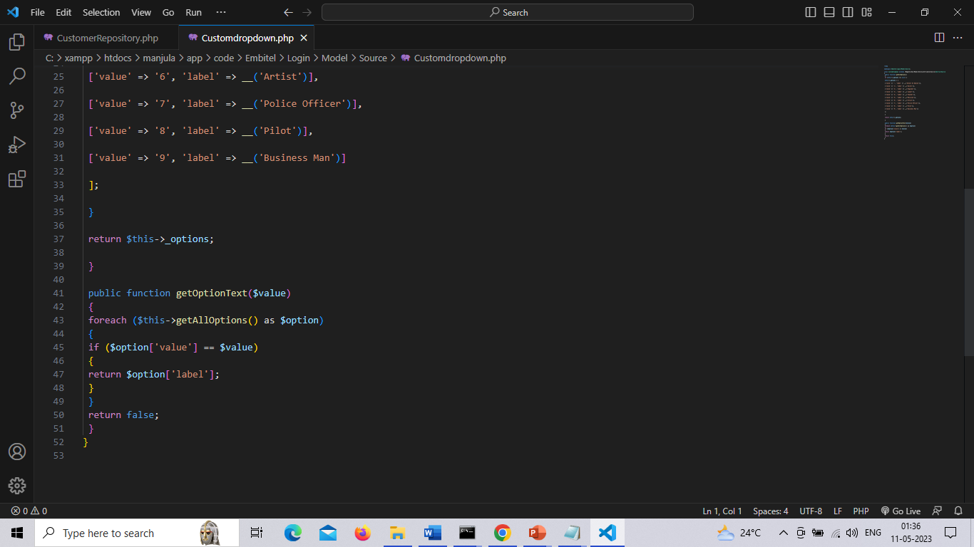

InstallData. Php

Used to add data in tables which are already created in our magento module.

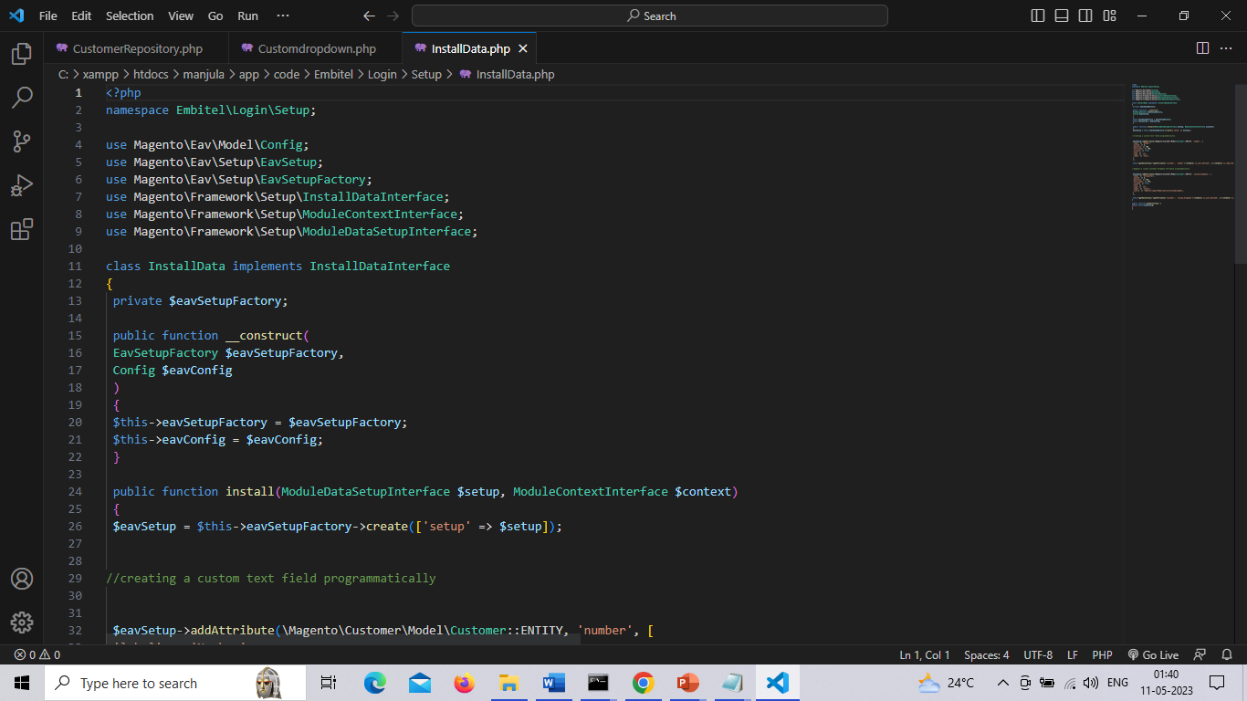

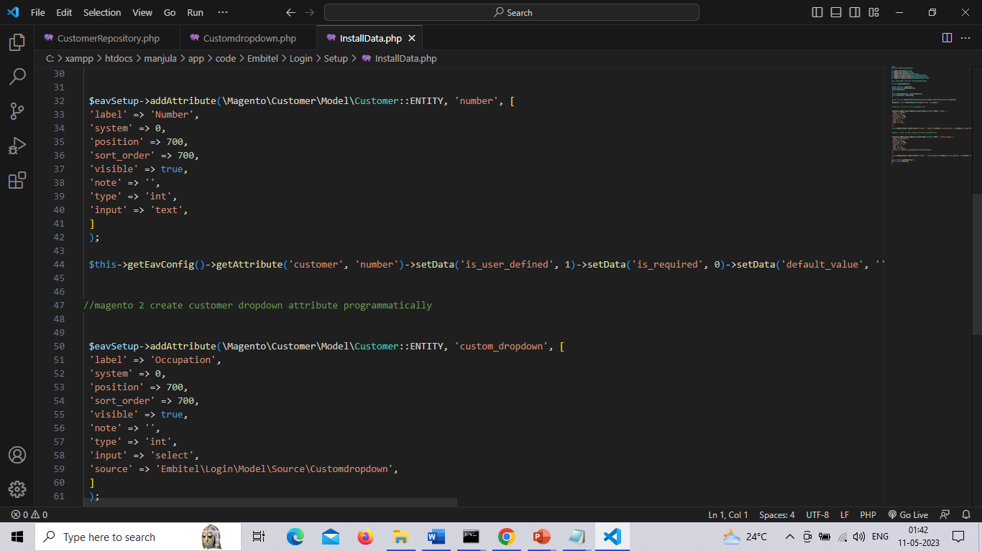

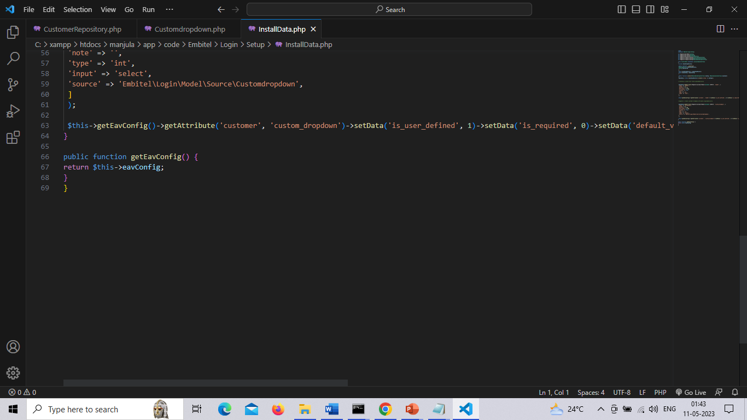

**UpgradeData.php**.

We need to add a custom attribute (**number and occupation**) for customer in Magento2 via an existing module, we have used  **UpgradeData.php**.

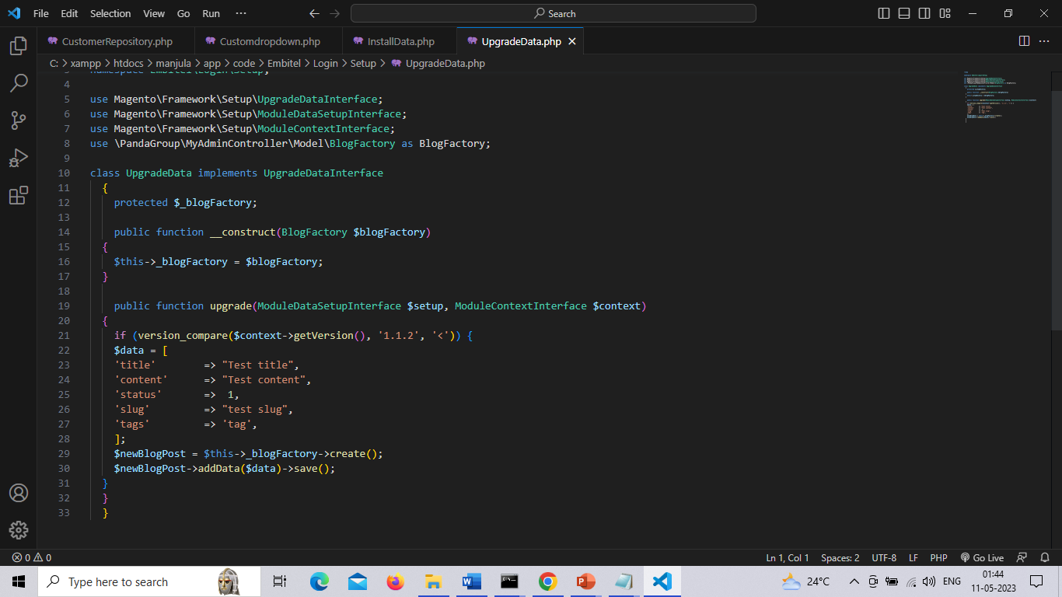

**Customer_listing.xml**

To add the column in admin

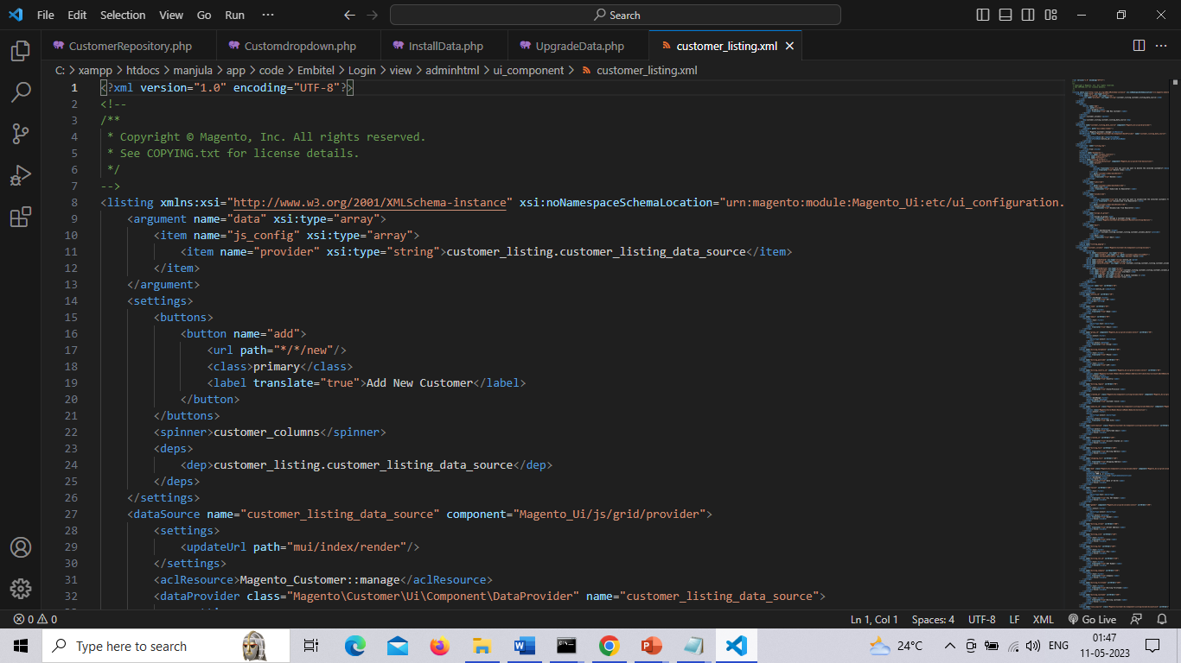

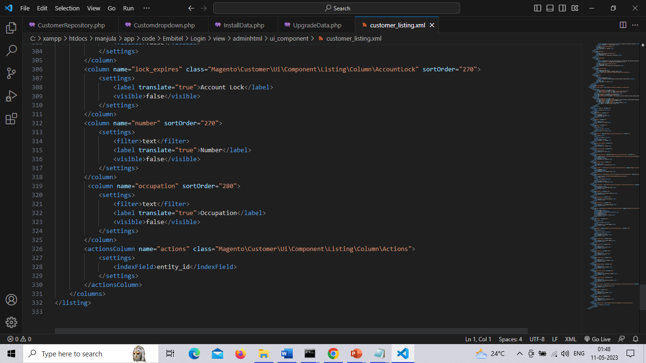

Info.phtml

